A Project Report On

“E-Commerce ShopWave”

Master of Computer Application Silver Oak College of Computer Application

Submitted To


Department of Computer Application

School of Technology, Design and Computer Application

Submitted By:
Student Name : Ayushi Salunke
Mitu Patel
Nisha Rana
Enrollement no : 190
147
285
Guided By: Mrs. Jeenal Panchasara
Department of Computer Application Silver Oak College of Computer Application
Academic Year:2025-26

Preface

This project report presents the development of an E-Commerce Clothing Website designed and implemented using PHP, MySQL, HTML, CSS, and JavaScript. The website is intended to provide a seamless and user-friendly online shopping experience for customers, while offering a robust and secure backend management system for administrators.
In today’s digital era, online shopping has become an integral part of the retail industry. Customers prefer browsing, selecting, and purchasing clothing items from the comfort of their homes, and businesses are increasingly adopting e-commerce solutions to expand their reach. Recognizing this need, the project focuses on building a responsive, secure, and scalable platform that caters to both customers and administrators.
The system allows customers to browse products, search by category, add items to the shopping cart, and place orders conveniently. Secure user authentication ensures that only authorized users can access their accounts. On the administrative side, features such as product management (CRUD), order tracking, user management, and message handling are provided to simplify operations.
This project serves as a practical implementation of full-stack web development concepts, integrating front-end design, server-side scripting, and relational database management. It highlights not only technical skills but also the understanding of business needs in the digital retail sector.
The development of this project has been an enriching experience, enabling the application of theoretical knowledge into a real-world scenario. It is hoped that this work will serve as a useful reference for future learners and developers who aspire to build scalable web-based applications.

Acknowledgment

The development of E-Commerce was a collaborative undertaking, and I am deeply grateful to all who contributed to its successful completion.

I extend my sincere appreciation to Jeenal Panchasara for his invaluable guidance, support, and expertise throughout this project. His insightful feedback and direction were instrumental in shaping the system's design and functionality.

I am also grateful to the Department of Computer Application for providing the essential resources and infrastructure that made the development of ShopWave possible. Their support was invaluable.

Furthermore, I would like to thank the cloth shop vendors and customers who generously participated in the testing phase. Their feedback was crucial in identifying areas for improvement and ensuring the system effectively addresses the real-world demands of a cloth in online environment.

This project would not have been possible without the collective efforts of everyone involved. I am truly grateful for their contributions and unwavering support.



Silver Oak College of Computer Application Department of Computer Application

CERTIFICATE

Date:

This is to certify that the project entitled “ShopWave” has been carried out by “Mitu Patel” under the guidance of Jeenal Panchasara in fulfillment of the Minor Project subject_Code at Silver Oak College of Computer Application in School of Technology, Design and Computer Application, Silver Oak University , Ahmedabad during academic year 2025-2026.

Internal Guide Head of Department

Index

Index
Sr. No | Title | Page Number
1 | Introduction | 1
2 | Abstract | 3
3 | Objectives | 5
4 | Existing System
4 | Methodology  - Requirements Analysis  - Software Requirement  - Hardware Requirement  - System Design:  - Use Case  - E-R Diagram  - Activity Diagram  - Data Flow Diagram | 6
5 | Data Dictionary | 13
6 | Screenshots | 16
7 | Project Outcomes | 17
8 | Future Scope | 18
9 | Conclusion | 19
10 | References | 20

INTRODUCTION
The rapid growth of the internet and advancements in web technologies have revolutionized the way businesses operate, shifting from traditional offline stores to online platforms. Among the most impactful innovations is e-commerce, which enables businesses to sell their products and services online, providing customers with the convenience of browsing and shopping from anywhere at any time. Within this landscape, the clothing and fashion industry has emerged as one of the most active domains in online retail, with customers increasingly relying on e-commerce platforms for purchasing apparel and accessories.
This project, E-Commerce Clothing Website, is developed using PHP, MySQL, HTML, CSS, and JavaScript. It is designed to provide a user-friendly, responsive, and secure online shopping experience while also offering robust administrative control. The system is structured to serve two primary stakeholders:
- Customers (End-Users):
Customers can register and log in to the system, browse clothing collections, view product details, add products to their shopping cart, update or remove items, and complete purchases through a secure checkout process. The platform also provides additional features such as search functionality, responsive design for multi-device access, and contact forms for customer queries.
- Administrators (Back-End Users):
Administrators are equipped with a comprehensive dashboard that allows them to manage products, categories, orders, and customer messages. Admins can perform CRUD (Create, Read, Update, Delete) operations on products, monitor customer orders, manage users, and respond to inquiries submitted through the contact form. The system also ensures role-based access control so that sensitive administrative features remain secure and accessible only to authorized users.
The website incorporates responsive web design principles, ensuring that all features — such as the header with a toggle menu, product pages, checkout form, and admin dashboard — adapt seamlessly to desktops, tablets, and smartphones. Features like the shopping cart with CRUD operations, search functionality, and checkout forms are implemented to closely resemble real-world e-commerce applications, thereby enhancing the learning and practical relevance of this project.
From a technical perspective, the project integrates front-end interactivity using vanilla JavaScript, server-side processing with PHP, and persistent storage with MySQL. The database is carefully structured with relationships between users, products, orders, and messages to ensure data integrity and scalability. Security measures such as password hashing, input validation, and session handling are also incorporated to safeguard user data.
In summary, the E-Commerce Clothing Website project is a complete solution for small to medium-scale clothing retailers who wish to establish an online presence. It reflects both technical competence in web development and an understanding of e-commerce business workflows, making it an ideal project for academic learning as well as practical deployment.

ABSTRACT
The increasing demand for online shopping platforms has transformed the retail sector, particularly in the clothing and fashion industry. Customers today prefer convenient, fast, and secure shopping experiences that allow them to browse and purchase products from anywhere at any time. To address this demand, the proposed project, E-Commerce Clothing Website, is developed using PHP, MySQL, HTML, CSS, and JavaScript. The system aims to deliver a responsive, role-based online platform that facilitates product browsing, shopping cart management, order checkout, and administrative control.
The website provides two main roles: customers and administrators. Customers can register, log in, browse products, add items to their shopping cart, modify or remove items, and place orders using a responsive and user-friendly interface. Features such as product search, responsive layout using CSS Grid, and contact forms further enhance the customer experience. On the other hand, administrators can access a secure dashboard where they can manage products (CRUD operations), orders, user accounts, and messages from customers. Role-based authentication ensures that only authorized users can access administrative functionalities.
Technically, the system integrates front-end design with vanilla JavaScript interactivity, server-side scripting in PHP, and relational database management with MySQL. Data integrity, consistency, and security are maintained through features such as input validation, password hashing, and session management. The project also emphasizes scalability by designing a structured database schema that supports extensions like reviews, categories, and order tracking.

OBJECTIVES
Primary Objective
- Build a secure, responsive e-commerce website for clothing using PHP and MySQL that enables smooth shopping and easy administration.
Specific Objectives
- Implement role-based authentication (user & admin) and secure session handling.
- Create a responsive header with toggle menu functionality using vanilla JavaScript.
- Develop product management (Create, Read, Update, Delete) for admins.
- Implement a shopping cart with add/update/delete operations and persistent storage.
- Provide an order checkout flow integrated with backend order storage and status management.
- Provide search and filtering capabilities for products.
- Implement contact/message handling and an admin message box.
- Design responsive pages (home, shop, about with reviews, contact, orders, cart, checkout) using CSS Grid and modern layout techniques.
- Ensure data consistency by designing a clear database schema and data dictionary.

METHODOLOGY

Requirement Analysis

    - Software Requirement:
The Software Requirements Specification (SRS) for ShopWave details the functional and non-functional requirements that the software must meet. This document serves as a blueprint for the development team and ensures that the system meets the needs of all stakeholders.

Functional Requirements:

Product Management:
Customers can browse menus from multiple vendors. Customers can customize orders (e.g., specifying ingredients, dietary options). Customers can add items to their cart and review their order. Customers can place orders and receive order confirmation (with a unique ID). Vendors can receive and manage incoming orders. Vendors can update order status (e.g., preparing, ready, completed). System can manage order queues and prioritize orders. System can handle order cancellations (by customer or vendor).

Payment Processing:
System integrates with multiple payment gateways (e.g., credit/debit cards, mobile wallets). System can process secure online payments. System can generate receipts for transactions. System can handle refunds (if applicable). System can support cash payments (processed at a designated counter).

Kitchen Display System (KDS) Integration:
Orders are automatically sent to the relevant vendor's KDS. KDS displays order details clearly (including customizations). Kitchen staff can update the status of items on the KDS. KDS can prioritize orders based on preparation time. KDS can generate reports on kitchen efficiency.

Order Management:
Vendors can add, edit, and remove menu items. Vendors can categorize menu items

(e.g., appetizers, entrees, desserts). Vendors can set prices for menu items. Vendors can manage menu availability (e.g., marking items as sold out).

Inventory Management:
System can track inventory levels for each vendor. System can generate alerts when inventory levels are low. Vendors can update inventory levels. System can generate reports on inventory usage.

Reporting and Analytics:
System can generate reports on sales data (by vendor, item, and time period). System can generate reports on popular items and peak hours. System can generate reports on customer preferences. System can provide data visualizations and dashboards.

User Management:
System can manage user accounts for customers, vendors, and management. System can assign roles and permissions to users. System can authenticate users securely.

Customer Management:
System can store customer information (optional, with privacy considerations). System can track customer order history. System can manage customer feedback and ratings.

Non-Functional Requirements:

Performance:
System should respond quickly to user requests. System should be able to handle a large number of concurrent users. System should have minimal downtime.

Security:
System should protect sensitive data (e.g., payment information) through encryption and access control. System should comply with relevant security standards.

Usability:
System should have a user-friendly interface that is easy to navigate. System should be intuitive and require minimal training.

Reliability:
System should be stable and reliable. System should have robust error handling and recovery mechanisms.

Scalability:
System should be able to handle increasing transaction volume and user base.

Maintainability:
System should be easy to maintain and update. Code should be well-documented and easy to understand.

Portability:
System should be able to run on different platforms (e.g., web browsers, mobile devices).

Availability:
System should be available to users during specified hours of operation.

This SRS serves as a living document and may be updated throughout the development process as needed. It's crucial for ensuring that Shopwave meets the needs of all stakeholders and delivers a high-quality user experience.

Operating System: Windows / Linux / macOS (development environment)

Web Server: Apache or Nginx (with PHP support)

Server-Side Language: PHP 7.4+ (or PHP 8.x recommended)

Database: MySQL / MariaDB

Client-Side: HTML5, CSS3 (including CSS Grid), JavaScript (vanilla)

Libraries / Tools (optional):

Composer (if using libraries)

PHPMailer (for email notifications)

Bootstrap or Tailwind (optional for faster styling; project currently uses custom CSS)

Git (version control)

phpMyAdmin (database management)

Development Tools: Code editor (VS Code, Sublime Text), browser developer tools

Relational: PostgreSQL (robust, scalable) or MySQL (common, cost-effective). Consider NoSQL databases like MongoDB if you anticipate highly flexible data structures or large volumes of unstructured data.

Cloud Platform (Optional):
AWS, Google Cloud, Azure (for hosting, scalability, and managed services). Not essential, but beneficial for deployment and scaling.

Hardware Requirement:

Processor (CPU): An eight-core or ten-core Intel Xeon E series processor or an equivalent AMD EPYC processor should be sufficient.
Development Machine:
  - CPU: Dual-core 2.0 GHz or better
  - RAM: 4 GB minimum (8 GB recommended)
  - Disk: 20 GB free space
  - Network: Internet connection for deployment and mail gateway (if used)
Server (for deployment):
  - CPU: 2+ cores recommended
  - RAM: 2 GB minimum (4 GB recommended for moderate traffic)
  - Storage: 50 GB or as required for product images and logs
  - Backup storage or object storage for images (optional)

System Design

    - Use Case:

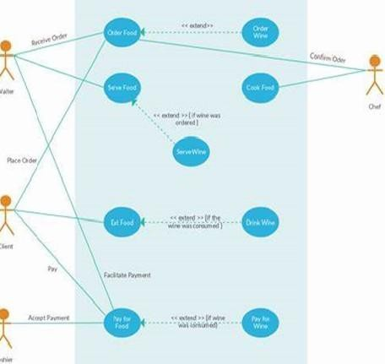

    - E-R Diagram
User:
Email
User name
Category
Conform Pw
Image
Price
User
Password
Product
have

have
Price
Order
Product
Wishlist
Add to card

Admin:
Admin name
Email
Product
Profile Image
Admin
Password
Category
have

have
Add Product

Price

Dashboard
Submit
Cloths

Add Category
Total Pending
Details
Total Complete
Add Image
Total user/admin

    - Activity Diagram

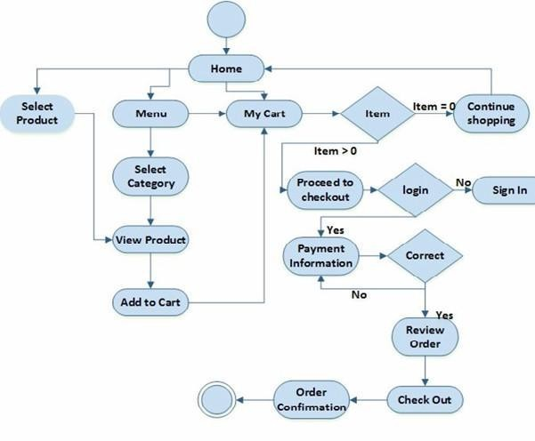

    - Data Flow Diagram

Level 0:
User
ShopWave
Admin

Level 1 DFD for User:
Add to Card
Product
User

Login

Order

Level 2 DFD Admin:

admin_id
user_type
Login
User
Admin

Manages
Category
Product

Orders
Manages Orders
placed_on

Users
Manages Users
user_id

Messages
Manages Messages

Logout

Second Level: (User)
Registration
Users
Users

user_tbt
Login
Users
user_tbt

View
Cloths

Add to Wishlist
Orders
prod_tb

Take Order
Orders

Logout

Second Level: (Admin)
Login
Users
Admin
user_tbt
Add Category
Cloths

Update
Cloths
prd_tb
Cloths

price

Delete item
Cloths

- DATA DICTIONARY
Users

Field | Data Type | Key | Description
user_id | INT AUTO_INCREMENT | PK | Primary key — unique user identifier
Name | VARCHAR(150) |  | Full name of the user
Email | VARCHAR(255) | UQ | User email (used to login)
password_hash | VARCHAR(255) |  | Hashed password
Role | ENUM(‘user’,‘admin’) |  | Role for access control
Phone | VARCHAR(20) |  | Optional contact number
created_at | DATETIME |  | Account creation timestamp

Categories

Field | Data Type | Key | Description
category_id | INT AUTO_INCREMENT | PK | Unique category id
name | VARCHAR(100) |  | Category name
slug | VARCHAR(120) | UQ | URL-friendly name
description | TEXT |  | Optional description

Products

Field | Data Type | Key | Description
product_id | INT AUTO_INCREMENT | PK | Unique product id
category_id | INT | FK -> categories(category_id) | Product category
Name | VARCHAR(200) |  | Product title
Slug | VARCHAR(220) | UQ | URL-friendly product name
Description | TEXT |  | Product detailed description
Price | DECIMAL(10,2) |  | Unit price
Stock | INT |  | Number of units available
Image | VARCHAR(255) |  | Main image path/filename
created_at | DATETIME |  | Timestamp added

Cart

Field | Data Type | Key | Description
cart_id | INT AUTO_INCREMENT | PK | Unique cart row id
user_id | INT | FK -> users(user_id) | Owner of the cart row
product_id | INT | FK -> products(product_id) | Product added to cart
product_name | VARCHAR(200) |  | Snapshot of product name
price | DECIMAL(10,2) |  | Snapshot of product price
quantity | INT |  | Quantity selected
added_at | DATETIME |  | When the item was added
Orders

Field | Data Type | Key | Description
order_id | INT AUTO_INCREMENT | PK | Unique order id
user_id | INT | FK -> users(user_id) | User who placed the order
total_amount | DECIMAL(12,2) |  | Sum of order items
Status | VARCHAR(50) |  | e.g. pending, paid, shipped, delivered, cancelled
shipping_address | TEXT |  | Shipping information snapshot
payment_method | VARCHAR(50) |  | e.g. card, netbanking, COD
created_at | DATETIME |  | Order placement time

Order _items

Field | Data Type | Key | Description
order_item_id | INT AUTO_INCREMENT | PK | Unique row id for item
order_id | INT | FK -> orders(order_id) | Associated order
product_id | INT | FK -> products(product_id) | Product ordered
product_name | VARCHAR(200) |  | Snapshot of product name
price | DECIMAL(10,2) |  | Price per unit at time of order
quantity | INT |  | Quantity ordered
messages

Field | Data Type | Key | Description
message_id | INT AUTO_INCREMENT | PK | Unique message id
user_id | INT NULL | FK -> users(user_id) | If logged in, reference to user
name | VARCHAR(150) |  | Sender name (for guest messages)
email | VARCHAR(255) |  | Sender email
subject | VARCHAR(255) |  | Message subject
message | TEXT |  | Message body
is_read | TINYINT(1) |  | 0 = unread, 1 = read
created_at | DATETIME |  | Submission time
reviews

Field | Data Type | Key | Description
review_id | INT AUTO_INCREMENT | PK | Unique review id
product_id | INT | FK -> products(product_id) | Reviewed product
user_id | INT | FK -> users(user_id) | Reviewer
rating | TINYINT |  | Rating (1-5)
comment | TEXT |  | Review comment
created_at | DATETIME |  | When review was posted
Admins(optional)

Field | Data Type | Key | Description
admin_id | INT AUTO_INCREMENT | PK | Unique admin id
user_id | INT | FK -> users(user_id) | Associated user account
privileges | TEXT |  | Comma-separated special permissions

- SCREEN SHORTS
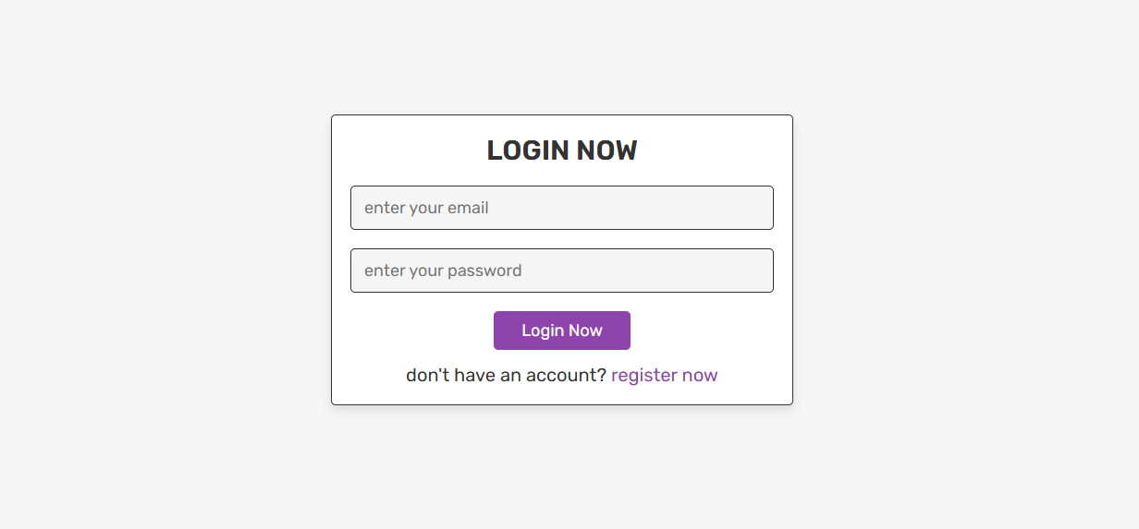

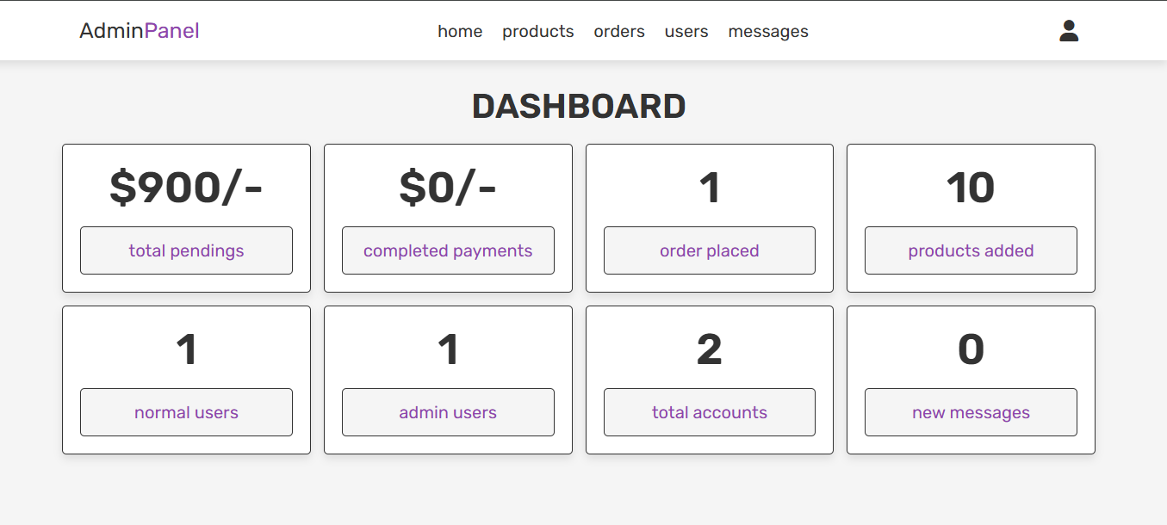

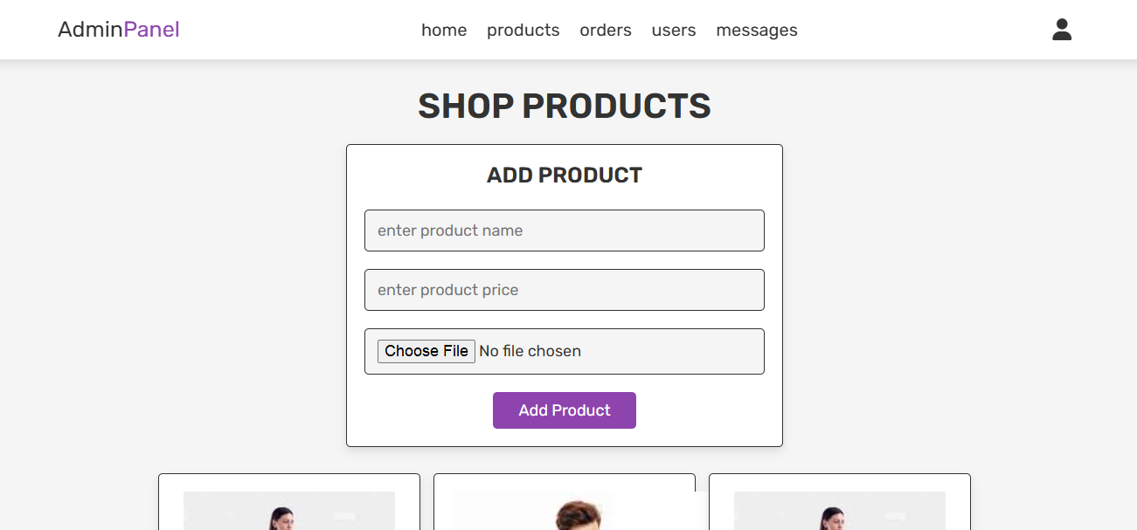

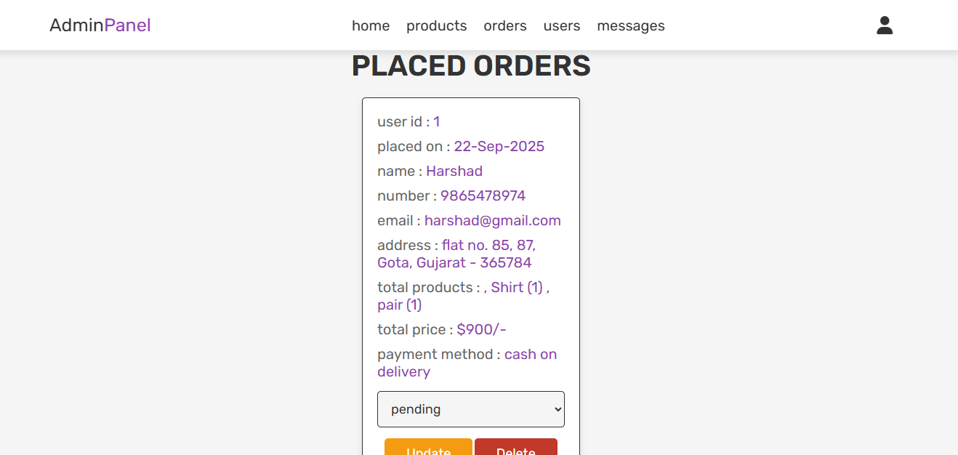

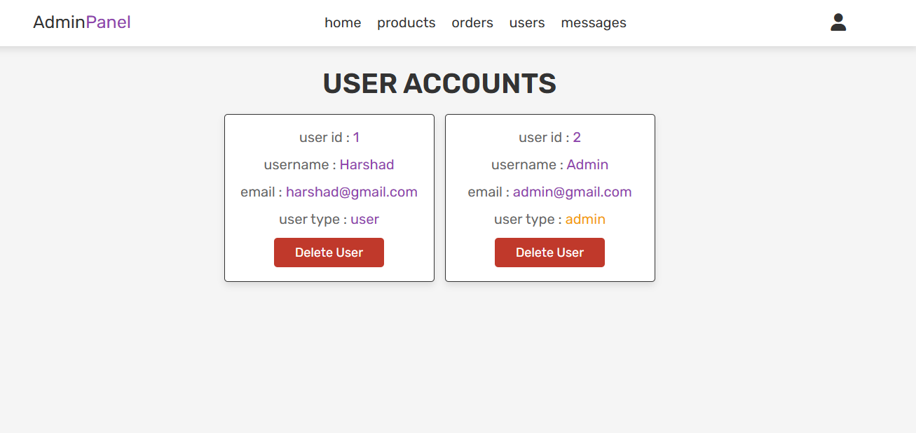
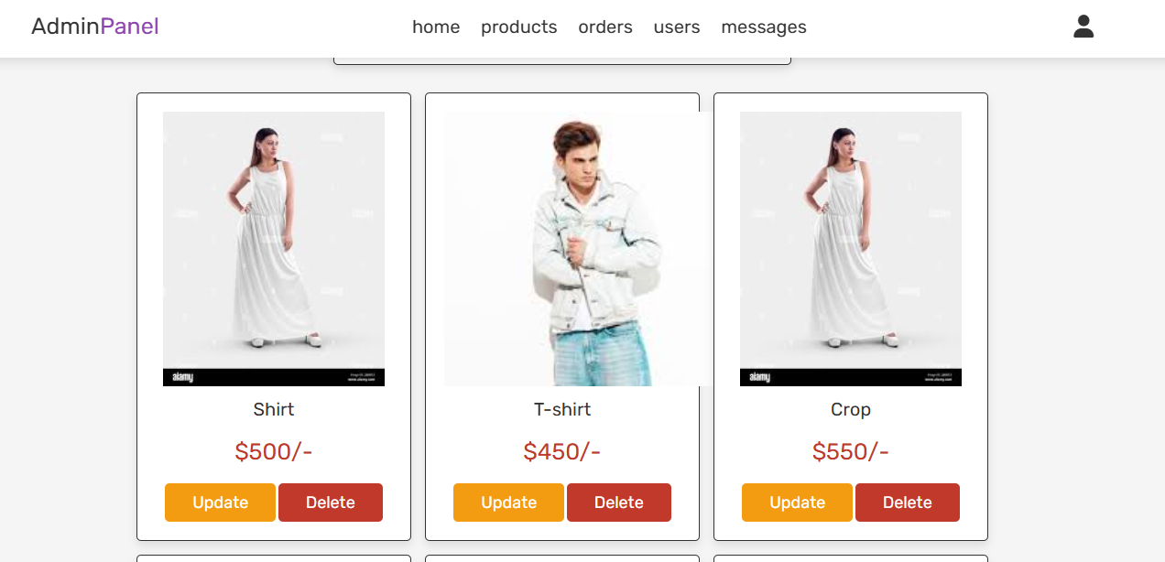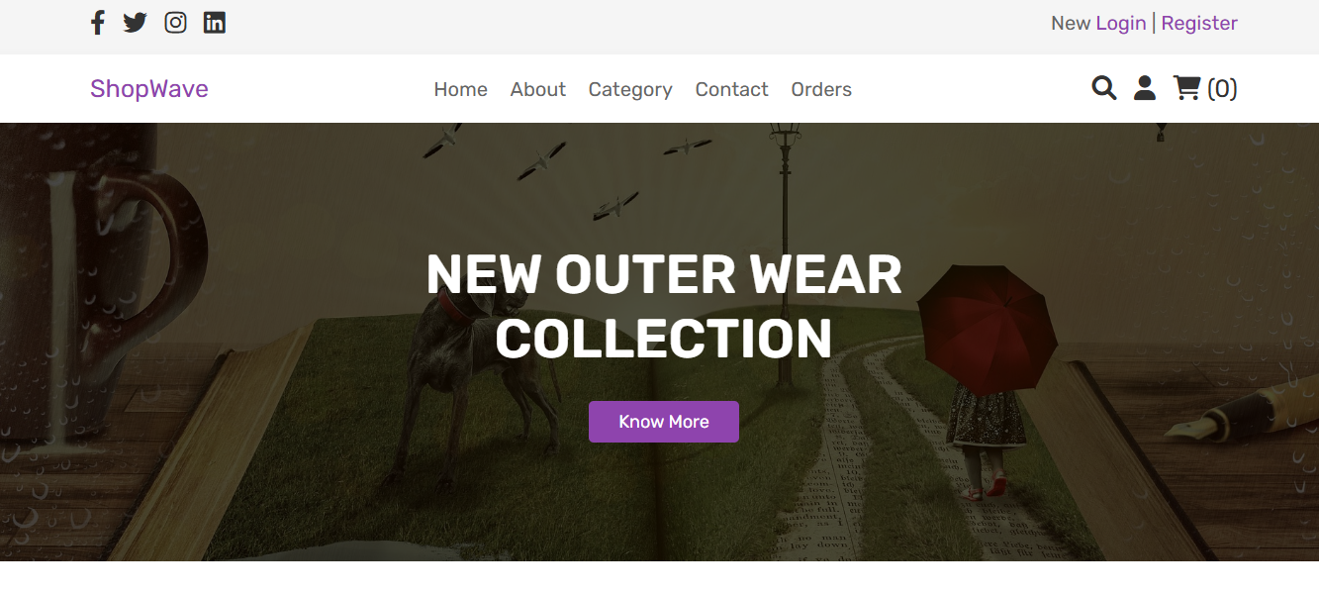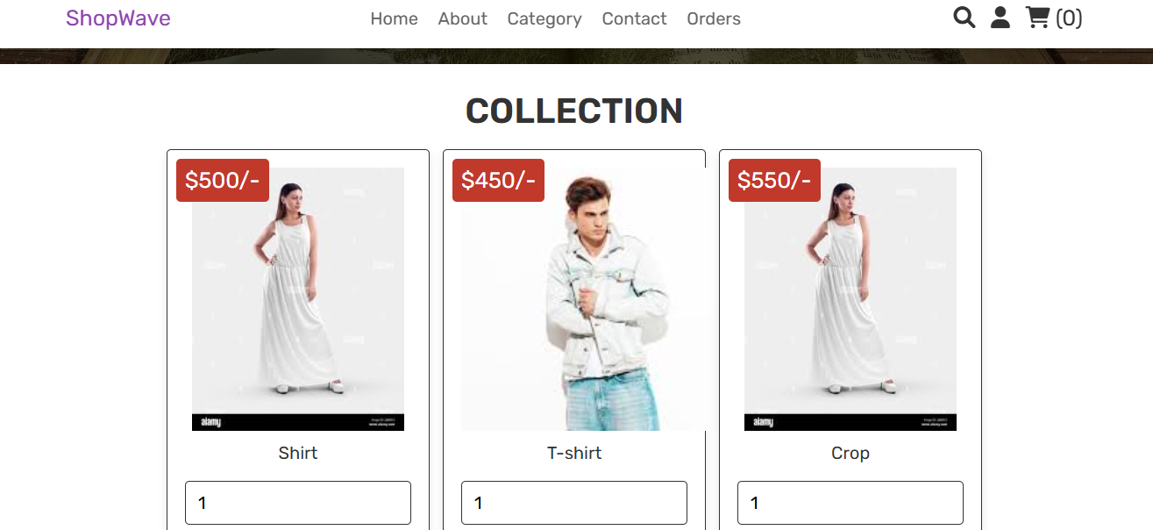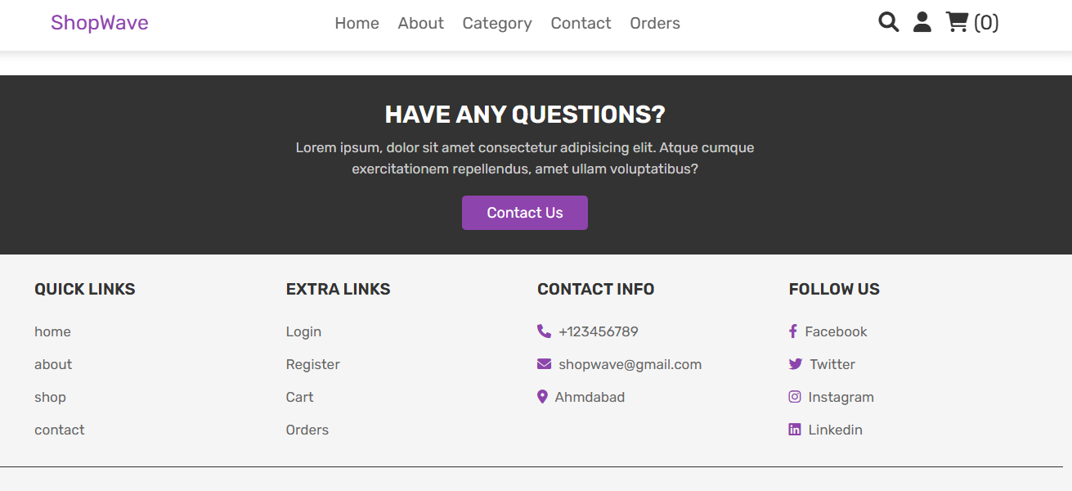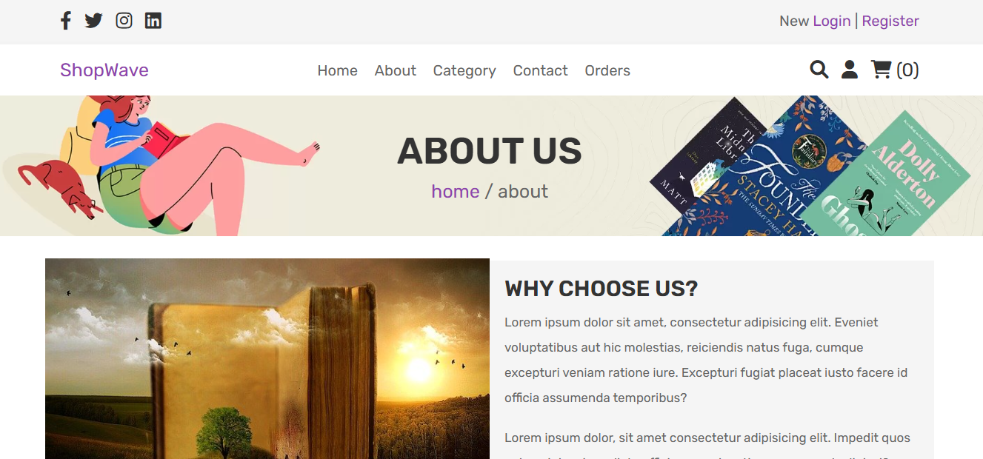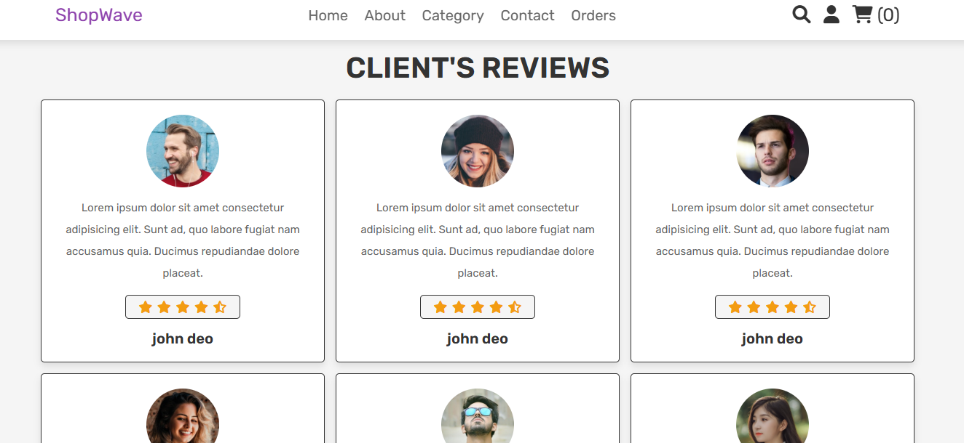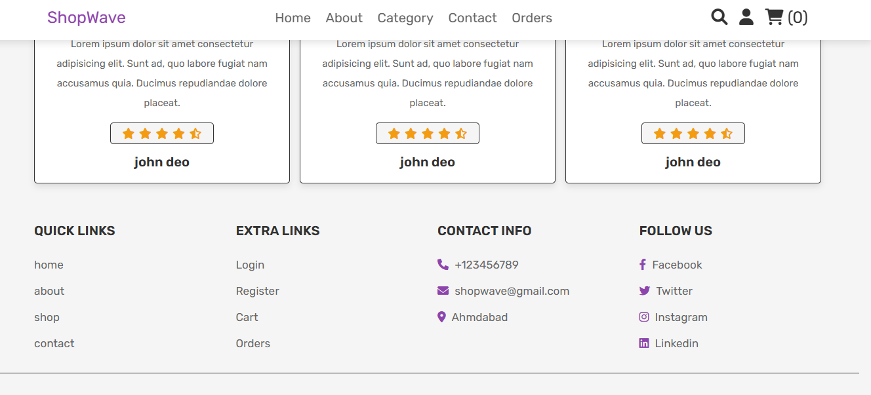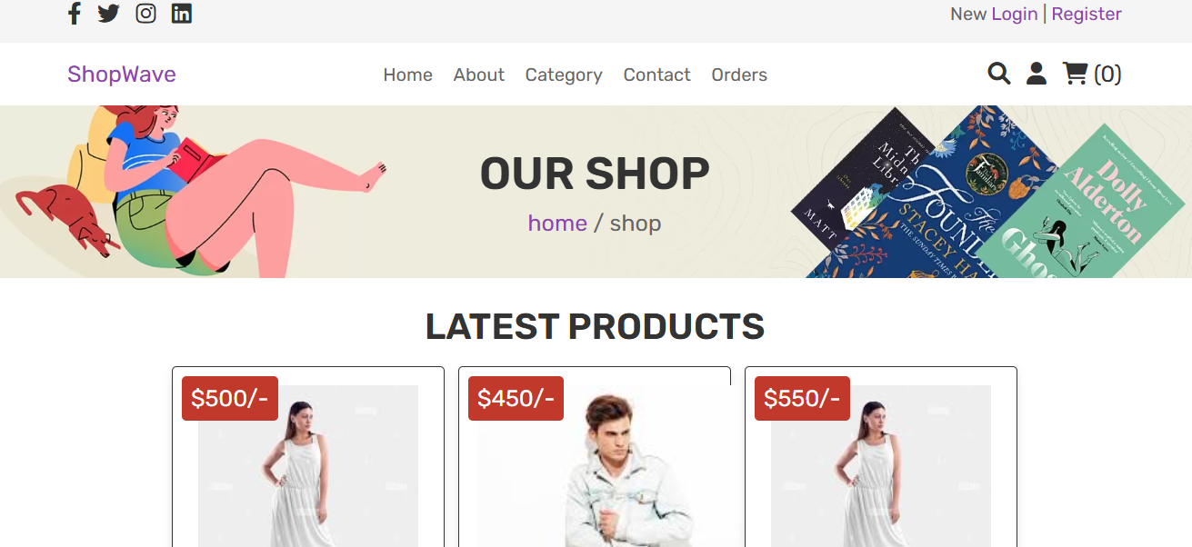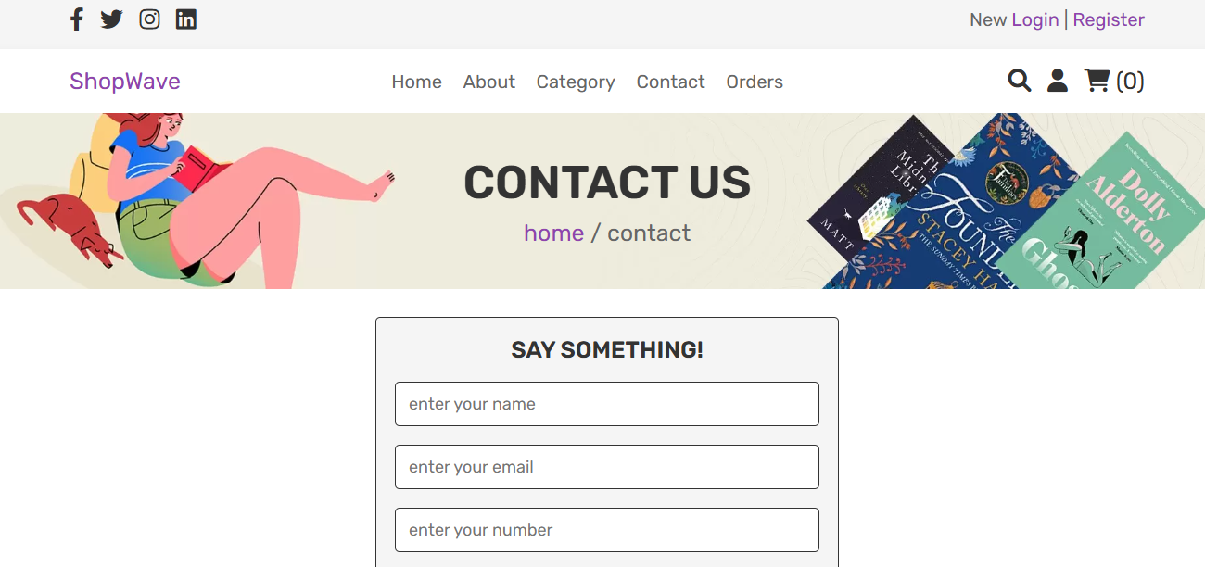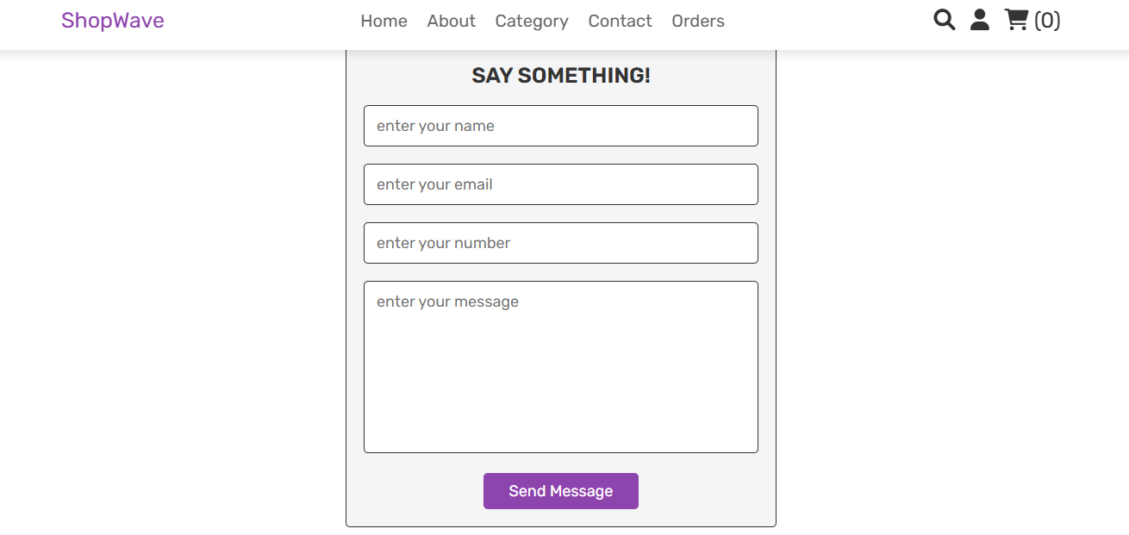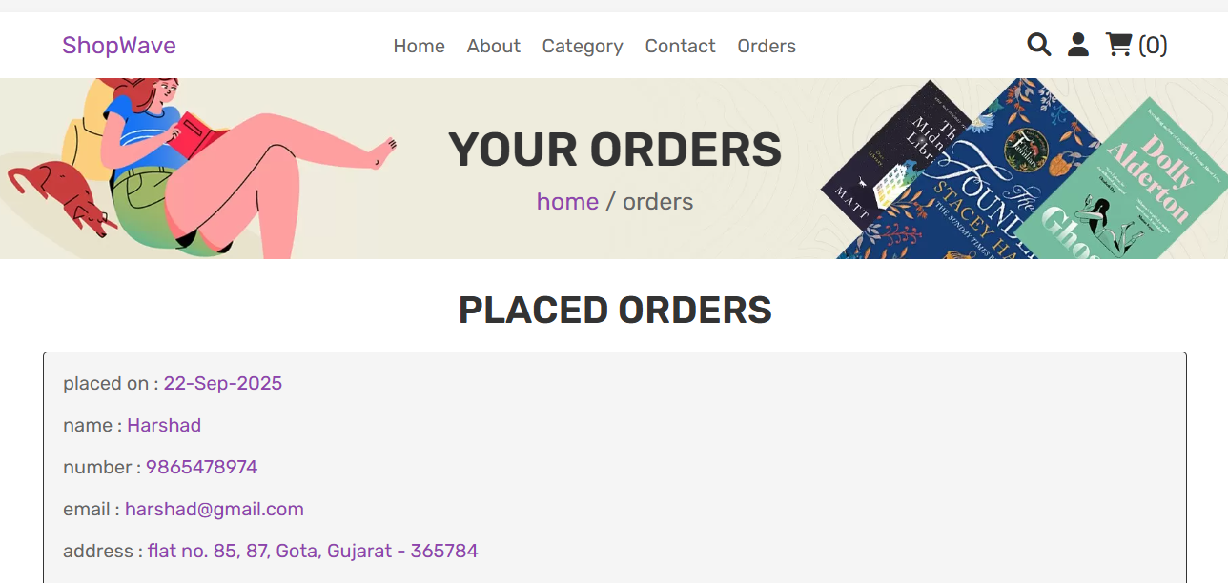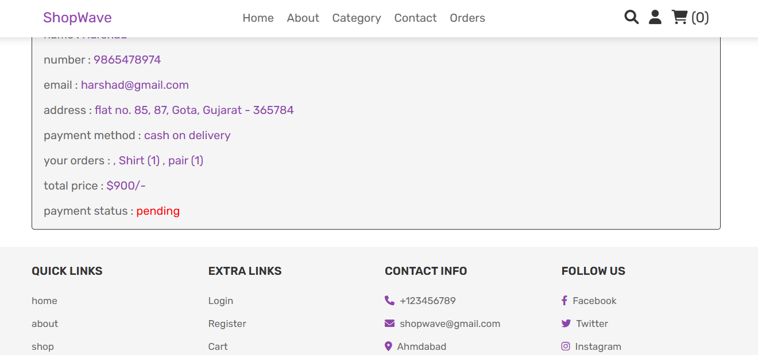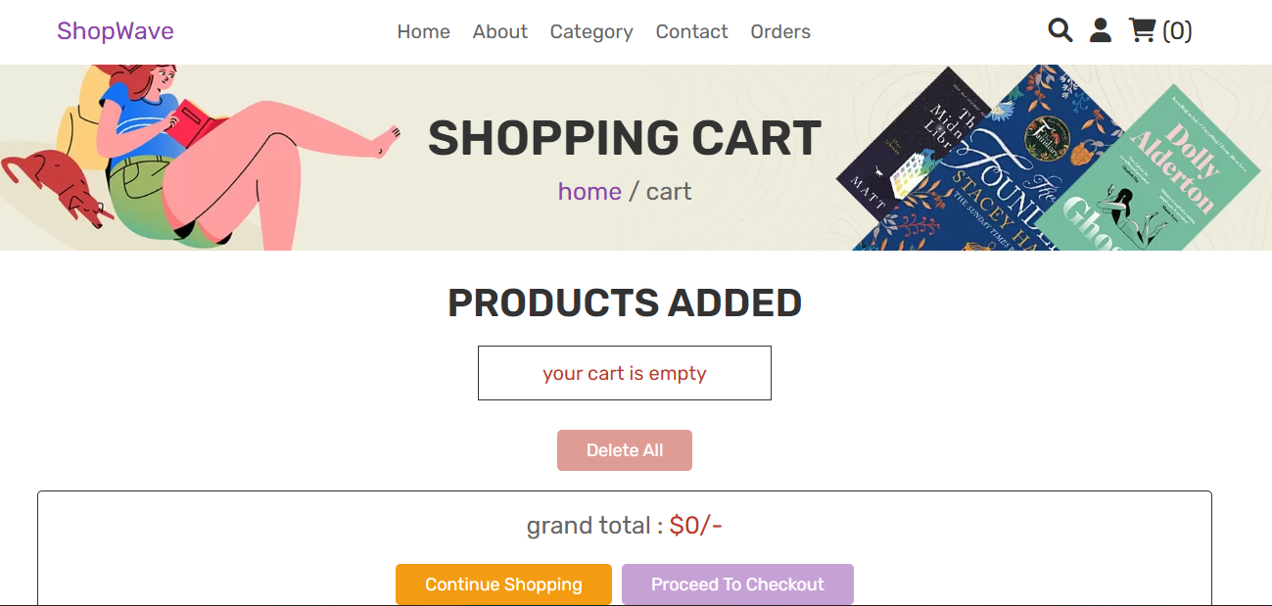
- PROJECT OUTCOMES

The successful implementation of the E-Commerce Clothing Website project resulted in a fully functional, responsive, and secure online shopping platform. The outcomes of the project can be summarized across both technical achievements and business/user benefits.
1. Functional Outcomes
Responsive User Interface:
The website adapts seamlessly to desktops, tablets, and mobile devices. Key pages — such as the home, shop, about, contact, cart, and checkout — are built with responsive design principles using CSS Grid and media queries, ensuring accessibility for all users.
Role-Based User System:
A secure authentication system was developed that distinguishes between customers and administrators. Customers can register, log in, and manage their shopping activities, while administrators have access to advanced dashboard functionalities.
Shopping Cart with CRUD Operations:
Customers can add, update, or remove items in their cart. The cart persists until checkout, and quantities/prices are accurately maintained.
Order Checkout and Management:
A complete checkout workflow was implemented, including capturing shipping details, placing orders, and updating order status. Administrators can view and manage these orders through the admin dashboard.
Product Management (CRUD):
Administrators can add, edit, delete, and view products in real-time. Each product record includes attributes such as name, description, price, stock, and image.
Search and Filter Functionality:
Customers can search for products by name or category. This enhances usability and ensures quick access to desired clothing items.
Contact and Messaging System:
Customers (including guests) can submit messages through the contact form, which are then stored in the database and made accessible to administrators via a dedicated message box.
2. Technical Outcomes
Database Design & Integrity:
A well-structured relational database was created with tables for users, products, categories, carts, orders, order items, messages, and reviews. Proper use of foreign keys ensures referential integrity.
Security Measures:
User credentials are stored using password hashing, input fields are sanitized to prevent SQL injection, and sessions are securely managed to ensure safe authentication and role handling.
Reusable and Modular Codebase:
The project adopts a modular PHP code structure with separate files for database connection, authentication, and CRUD functionalities. This makes the system more maintainable and extendable.
Interactivity with Vanilla JavaScript:
A toggle-based responsive navigation menu, form validation, and dynamic UI updates were implemented using vanilla JavaScript, ensuring lightweight interactivity without heavy dependencies.
3. Learning Outcomes
Strengthened understanding of full-stack web development by integrating front-end, back-end, and database technologies.
Gained hands-on experience in responsive design principles and layout management using CSS Grid.
Learned the importance of system modeling (Use Case Diagrams, ER Diagrams, Activity and Data Flow Diagrams) in planning before implementation.
Developed awareness of security best practices (password hashing, input validation, session handling).
Enhanced knowledge of project planning and documentation, including requirement analysis, design, testing, and reporting.
4. Business/User Outcomes
Provides a cost-effective solution for small and medium-scale clothing retailers to establish an online presence.
Improves customer convenience by offering 24/7 access to clothing collections.
Enables centralized management of products, users, and orders, reducing administrative workload.
Strengthens customer engagement through reviews, messages, and a responsive design that enhances user experience

FUTURE SCOPE

The E-commerce Clothing Website has been successfully developed with essential features such as responsive design, secure authentication, shopping cart functionality, and an admin dashboard for product and order management. However, there remains significant scope for future enhancements to improve its usability, efficiency, and scalability. One of the key improvements will be the integration of online payment gateways such as UPI, PayPal, or credit/debit cards to enable secure and seamless digital transactions. In addition, a dedicated mobile application for Android and iOS can be developed to provide a better user experience and increase customer engagement through push notifications and one-click checkout. The inclusion of artificial intelligence will further enhance the system by providing personalized recommendations, dynamic pricing, and customer behavior analysis. Furthermore, an automated inventory and supplier management system can be integrated to track stock levels, manage suppliers, and streamline logistics. Real-time order tracking can also be implemented to allow customers to monitor their purchases after checkout. For global adaptability, the website may include multi-language and multi-currency support. Advanced analytics and dashboards will give administrators deeper insights into sales performance and customer behavior, while live chat or chatbot-based customer support can enhance communication and improve customer satisfaction. These enhancements will ensure that the system evolves into a more advanced, reliable, and competitive e-commerce platform.

CONCLUSION

The E-commerce Clothing Website project demonstrates the successful design and development of a responsive, secure, and user-friendly platform for online shopping using PHP, MySQL, HTML, CSS, and JavaScript. The project fulfills its main objectives by providing a convenient platform where customers can browse clothing collections, manage their shopping carts, place orders, and interact with the business through messages, while administrators can manage products, users, orders, and messages effectively through a dedicated dashboard.
The implementation of responsive design ensures accessibility across devices, and the role-based authentication system ensures secure and controlled access to both users and administrators. Beyond the technical aspects, the project highlights the importance of systematic planning, requirements analysis, and database design in building reliable web-based systems. It not only meets the present requirements of an e-commerce platform but also establishes a strong foundation for future enhancements, including mobile application development, payment integration, and AI-driven personalization. Overall, this project proves to be a valuable step in bridging business needs with technology, offering a scalable solution for small and medium-sized retailers to expand their online presence and improve customer convenience.

REFERENCES

- This project was developed with the guidance of several academic resources, online tutorials, and official documentation.
- Books such as PHP and MySQL Web Development by Luke Welling and Laura Thomson, and Head First PHP & MySQL by Lynn Beighley and Michael Morrison provided fundamental insights into PHP-MySQL integration.
- Official resources such as the PHP Documentation, MySQL Documentation, and MDN Web Docs were extensively used for understanding technical implementations and web standards.
- Learning platforms such as W3Schools, GeeksforGeeks, and TutorialsPoint contributed practical examples and coding practices.
- https://www.youtube.com/redirect
- https://youtu.be/1Df_VJ4aL9o?si=yZtadNU3ac-xR9dN

